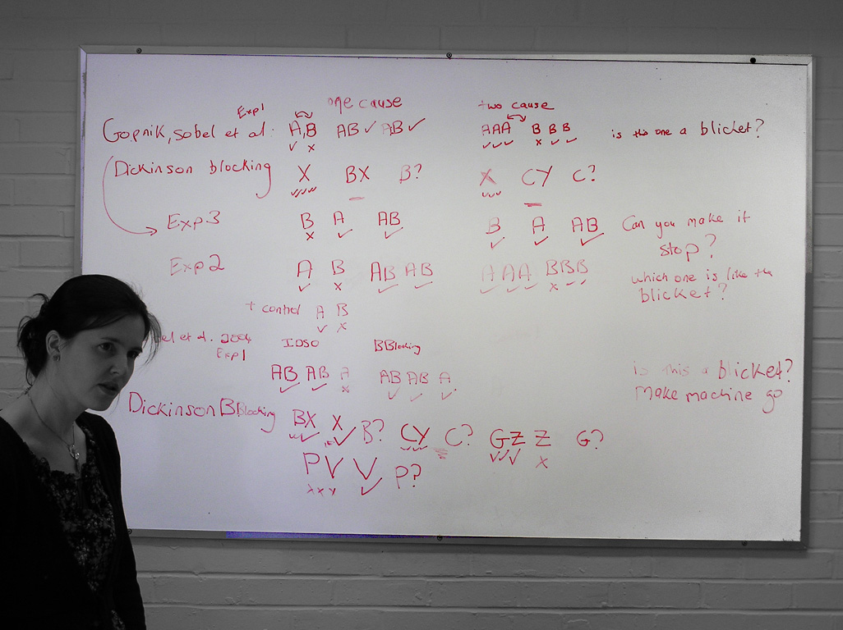19/4/2006

Paper {Gopnik, 2001 #1027}: Gopnik, Alison, David M. Sobel, Laura E. Schulz and Clark Glymour (2001), "Causal learning mechanisms in very young children: Two, three, and four-year-olds infer causal relations from patterns of variation and covariation". Developmental Psychology, 37(5), pp. 620-629.

Gopnik argues against a simple Covariation account of causal judgement (i.e. against the idea that we decide whether A is a cause of E by considering how often A and E have occurred together).

Experiment 1 {Gopnik, 2001 #1027}
 | test |  |  | control
 | A B | AB AB |  | A A A | B B B
 | ✓ ✗ | ✓ ✓ |  | ✓ ✓ ✓ | ✗ ✓ ✓
Test question: Is this one a blicket? (holding up each in turn)
Measures: (a) How much more likely are children to pick A over B? (b) Difference between test and control conditions: are children less likely to say that B is a blicket in the test condition than the control?
Gopnik’s claim: A is screening off B in the test condition.
Our questions: (1) How does this compare to Dickinson’s screening off / blocking paradigm? (2) Is there any room in Gopnik’s account to explain any differences that order of presentation might make? (3) Is there an order of presentation effect in the control condition? And would you get an order of presentation effect if you presented the compound trials (AB) first in the test case?

Dickinson’s blocking paradigm {Dickinson, 2001 #1028}
 | test |  |  | control
 | A … | AB AB … |  | A … | CD CD …
 | ✓ … | ✓ ✓ … |  | ✓ … | ✓ ✓ …
Test question: is B a cause? [becomes ‘Is C a cause?’ in the control condition]
Differences between this paradigm and Gopnik’s (above): (a) Dickinson uses many more trials and a much more complex scenario. (b) He never shows B✗. (c) And he uses a compound in the control as well as the test. So for Dickinson, the key difference between the test and the control is the history of one of the compounds.

Experiment 3 {Gopnik, 2001 #1027}
 | one cause |  |  | two cause (control)
 | B A | AB |  | B A | AB
 | ✗ ✓ | ✓ |  | ✓ ✓ | ✓
[While A is still on the machine, add B. Then ask, Can you make it stop?]
Measure: Do children take off both blocks in the two cause situation more often than in the one cause situation?

Bases of Gopnik’s argument appear to be:
(a) Associationist account couldn’t explain interventions children make
(b) Associationist account can’t explain backwards blocking
(c) Children learn much quicker than associative accounts would suggest. (Debatable: associationist experiments do tend to involve many presentations, but perhaps only because the situations are more complex. And arguably the situations have to be more complex to evoke automatic learning mechanisms rather than general reasoning.)

Experiment 2 {Gopnik, 2001 #1027}
 | test |  |  | control 1
 | A B | AB AB |  | A A A | B B B
 | ✓ ✗ | ✓ ✓ |  | ✓ ✓ ✓ | ✗ ✓ ✓
 |  |  |  | control 2
 |  |  |  | A B
 |  |  |  | ✓ ✗
[same as Experiment 1 with an additional control designed only to ensure they understand the question. Actually CH would argue that from Gopnik’s point of view there should be no different in performance on the test case and the second control condition since the AB compound presentations add no new information.]

Test question, forced choice: Which one is the blicket? [It’s forced choice to avoid the possibility that children tend to say yes]

Our question: what’s the impact of presenting B✗ before the conditions?

We noted two interesting variations on Gopnik’s experiment:
 | test |  |  | control
 | A | AB AB |  | A A A | B B
 | ✓ | ✓ ✓ |  | ✓ ✓ ✓ | ✓ ✓
 | B | AB AB |  | A A | B B B
 | ✗ | ✓ ✓ |  | ✓ ✓ | ✗ ✓ ✓

Paper {Sobel, 2004 #726}: Sobel, David M., Joshua B. Tenenbaum and Alison Gopnik (2004), "Children's Causal Inferences from Indirect Evidence: Backwards Blocking and Bayesian Reasoning in Preschoolers". Cognitive Science, 28, pp. 303-333.

Experiment 1
Gopnik name | indirect screening off |  |  | backwards blocking |  | control for both  (do they understand the question)
 | AB AB A |  |  | AB AB A |  | A B
 | ✓ ✓ ✗ |  |  | ✓ ✓ ✓ |  | ✓ ✗
Compare Dickinson’s backwards blocking paradigm {Dickinson, 2001 #1028}
Dickinson name | retrospective generative | control for r.g. |  | backwards blocking | control for b.b.
 | AB AB A | AB AB |  | AB AB A | AB AB
 | ✓ ✓ ✗ | ✓ ✓ |  | ✓ ✓ ✓ | ✓ ✓

Test questions: Is this a blicket? (for each A, B). Can you make the machine go?

Measure: Is there a difference between indirect screening off and backwards blocking?

Our issues: (1) Gopnik assumes an associationist would not predict a difference between screening off and backwards blocking; but actually Dickinson would because he thinks learning occurs in the final trial in the case of indirect screening off but not backwards blocking. (2) If you understood the question as a forced-choice and answered on the basis of a very simple correlation mechanism (the more often a stimulus appears with an effect the more likely you are to judge it is a cause), then your responses to indirect screening would differ from your response to backwards blocking. [Gopnik’s Experiment 2, below, tackles (2) but not (1).]

Dickinson {\, 2001 #1028} doesn’t find any backwards blocking in adults (he finds performance no different from the control) but he does find ‘retrospective generative’. This he explains with the Russian-soldier-associates-communism-with-paychecks-idea.

Gopnik assumes an associationist will predict no difference between indirect screening off and backwards blocking. But Dickinson’s view implies that there will be a difference (and he found one: {Dickinson, 2001 #1028@10–11, fig 2}.)

Dickinson’s retrospective preventative’ condition {Dickinson, 2001 #1028}
 | test | control
 | AB … A | AB …
 | ✗ … ✓ | ✗ …

Experiment 2 {Sobel, 2004 #726}
As experiment 1, but 4-year-olds since 3-year-olds don’t appear to do backwards blockings {Sobel, 2004 #726@318}. Plus these control conditions to show that children aren’t interpreting the question as a forced choice …
 | control |  | control
 | A B B |  | A B C
 | ✓ ✓ ✓ |  | ✓ ✓ ✗

Our objection: this control isn’t sufficient because children might be interpreting the question as a forced choice only when compounds are presented. More importantly, we object to Gopnik’s original controls on the basis that they don’t involve compounds, and this rather than any learning may explain the difference in results. Gopnik needs to add controls like those in Dickinson’s paradigm.

Our issue: What about developmental differences? Gopnik appears to have nothing to say, despite finding big differences between 3- and 4-year-olds.

Experiment 3 {Sobel, 2004 #726}
This is done in two conditions, rare (1/10 items are blickets) and common (9/10 items are blickets). The aim is to show that children do backwards blocking when and only when blickets are rare. This is predicted by Gopnik’s view but not by any other proposal about learning.
 | test |  | control
 | AB A |  | AB
 | ✓ ✓ |  | ✓
Test question: Is B a blicket?
Results: 3-year-olds do badly but 4-year-olds say that B is not a blicket in the rare condition and they say that B is a blicket in the common condition. In the control they almost all say that B is a blicket regardless of the background frequency (which is correct: in this case, B is more likely than not to be a blicket even in the rare condition).
Our objection: perhaps what explains the appearance of backwards blocking in the rare condition is the children’s assumption that only one of A or B can be the blicket; in that case, showing them that A is the blicket rules out the possibility of B being a blicket. But why might children assume this? Because (1) pre-trial learning involves a set up where only one of two things are blickets and children have to discover which, and (2) the rare condition involves only 1 of 10 things being a blicket.

Thoughts about experiments to do

First, look for order effects?
 | A AB AB |  | AB A AB |  | AB AB A
 | ✓ ✓ ✓ |  | ✓ ✓ ✓ |  | ✓ ✓ ✓
TM suspects there’s a whole bundle of stuff going on including primacy and recency effects and children tending to pay too much attention to negative trials.

Second idea: contrast each of blocking and backwards blocking with (a) their respective controls and (b) with each other. When testing against each other, the only difference is the order of stimuli—which for Gopnik shouldn’t matter (we think).

 | test | control
blocking | A AB B? | A CD C?
backwards blocking | AB A B? | CD A C?

Why do this? Partly because we’re not convinced by Gopnik’s evidence that children do either blocking or backwards blocking.

